Brandon Boyle
Team Mini Project 3
24 Feb 2026
bboyle@bellarmine.edu

The goal of this project is to analyze a chemical manufacturing process in order to determine the most cost-effective way to handle their liquid waste. Based off the information provided, I thought it would be best to use Microsoft Excel and its Solver tool in order to get a solution that maximized profit for the company.
The very first thing I had to do was create a cost analysis that showed be the profit per pound for the primary product, product K, and product M. To do this I used the given cost analysis. To get the profit per pound for the primary product, I added up the variable cost and divided by 12,000 (how much primary product was made last month). From there I subtracted that number from 5.7, which is how much the PP sells for. This gave a net profit of $2.49 per pound. I then found the net profit for X and Y. I divided the cost of X by 12,000, and the cost of Y by 24,000 (since 2lbs of Y go into making 1lb of PP). From there I used those numbers in order to find the net profit of K and M. I took the respective product, X or Y, and dived by 2, in order to get the per pound price, then I added the cost of labor. This gave me a net profit of $-0.07 for K, and $0.19 for M. The final table is below.
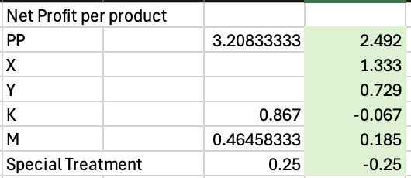
After creating the cost analysis, I could begin constructing my constraints. For this problem, I ended up with four different constraints. The first two were the constraints about how much raw material I had. I had to make sure that the usage stayed under or equal to the 7500lbs of X and 9000lbs of Y. Next I had to make sure the amount of waste used equaled the amount of PP produced. For every one pound of PP produced, one pound of waste was generated. And that waste had to be disposed of. Finally, I had the non-negative constraints, making sure no numbers ended up being negative. The full list of constraints is below.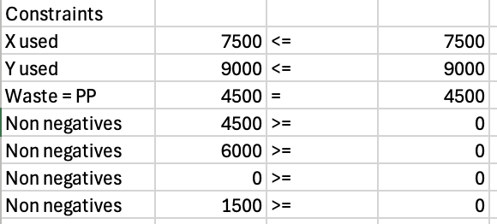
Now that I had my constraints, I was able to used the solver tool in Excel in order to get my final answer of the optimal production and waste management solution. Written out, the final solution sounds like this, all 9000lbs of Y will be used with 4500lbs of X in order to create 4500lbs of PP. This will also give us 4500lbs of waste to deal with. Since there is no more Y left, the company cannot make any product M. Instead, they must incur a loss. Since producing product K losses less money than treatment, they company should use the remaining 3000lbs of X and mix it with 3000lbs of waste in order to create 6000lbs of product K. And finally, with the remaining 1500lbs of waste, that will be treated and dumped into the water. The final table is below.
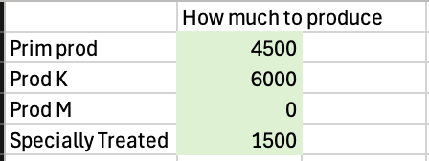
Unfortunately, this solution will result in a loss for the month. The total profit ended up being $-7062.50. In order to fix this, the company must think about providing additional raw materials. An increase in X and Y would eventually turn a profit. However, the increase in Y should result in twice as much Y as X, this will ensure there is no left over X that will have to be used to create K and incur a loss.
Next lets look at the sensitivity analysis of the objective function coefficients.
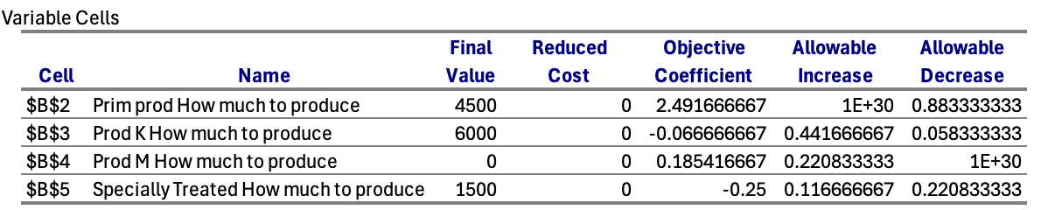
Starting with the primary product. This is the most profitable product and with an allowable decrease of 0.883, this proves that. Even if the coefficient drops to 1.6, PP will still be the best option. Next we can see that product K is not profitable and it would need a sizable increase in order to become a good solution. With an allowable increase of 0.44, once it has increased past that, product K would become a good option. Now product M is profitable, but it is driven by the available resources. The coefficient could drop by a lot and nothing would change. As long as Y is being used to create PP, there will be no product M being created. Finally for the treatment, there is a little bit of wiggle room that is allowed before the solution changes, but its interesting that the coefficient could drop to around -0.36 before another solution will be found. Overall the solution that we found is very stable.
When thinking about the accountant’s suggestion of getting rid of product K, on the surface it may seem like a good idea. Overall product K has a net profit of -0.06 cents, which isn’t great and may explain why the accountant thinks we should get rid of it. But when looking at ways to eliminate the waste produced, making product K isn’t a bad option, and as you can see, the solution to maximize profit in this problem involves making 6000lbs of it. This is because while it may incur a loss, it doesn’t lose as much money as treatment. So while the suggestion may seem reasonable, making product K is actually saving the company money compared to the alternative of putting 4500lbs of waste through treatment.
So to wrap everything up, the chemical manufacturing company, with the current supplies they have, they should produce 4500lbs of the primary product, 6000lbs of product K, and they should treat the remaining 1500lbs of waste. All of this together will incur a loss of $7062.5. In order to turn a profit, the company must increase the amount of X and Y they have.

